

***Дисциплина: Учебная практика***

**Отчет по выполнению задания на тему: «Lesson 8».**

**Выполнил студент:**

Зверев Н.Д.

Группа: **1-ИСП11-18**

**Проверил преподаватель:**

Мартиросян В.А.

.

Москва 2022 г.

**Задание №8.**

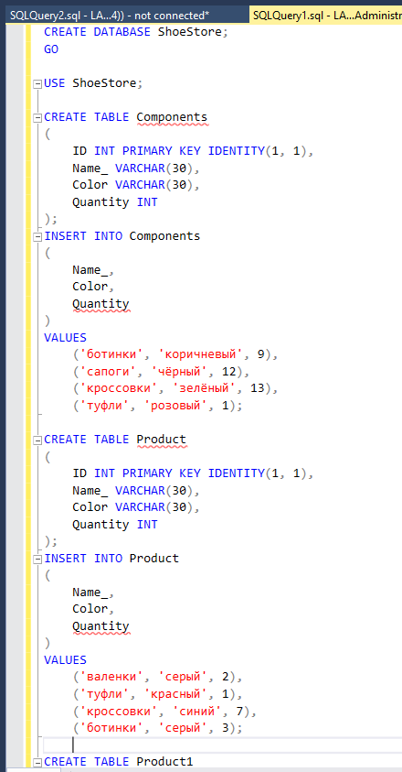

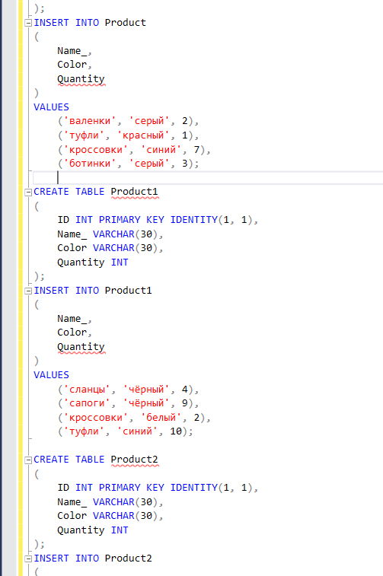

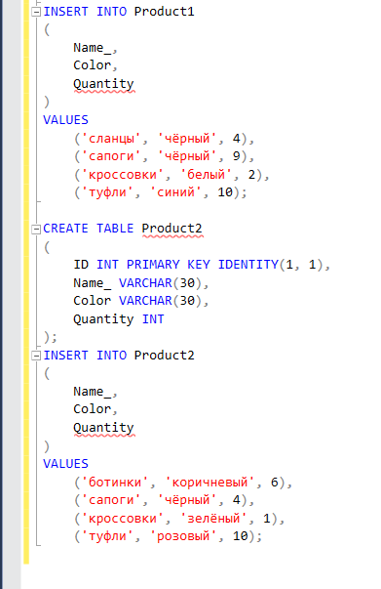

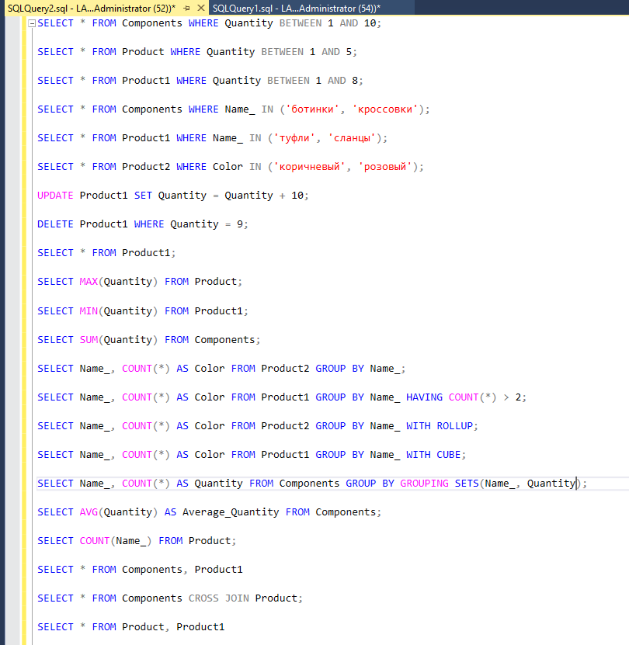

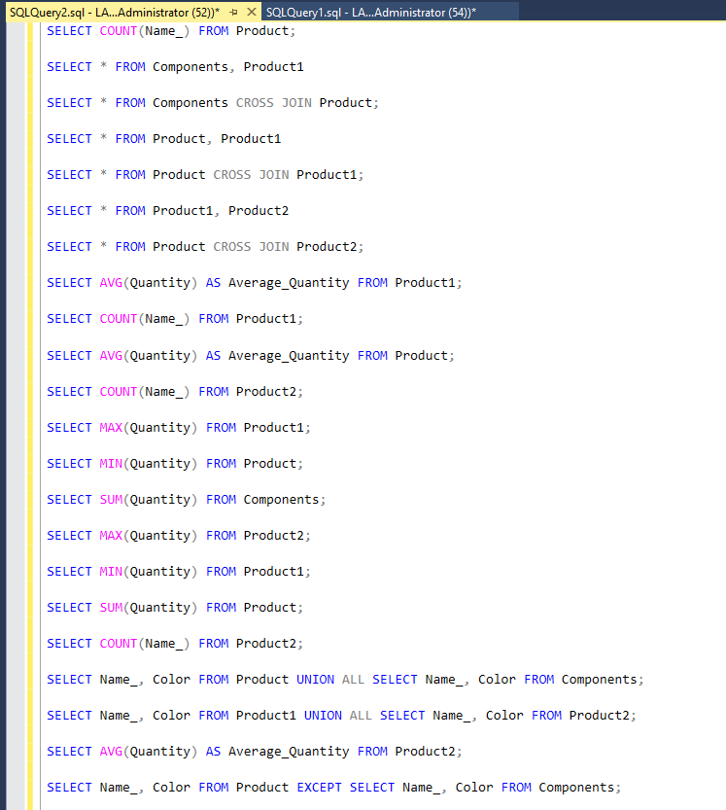

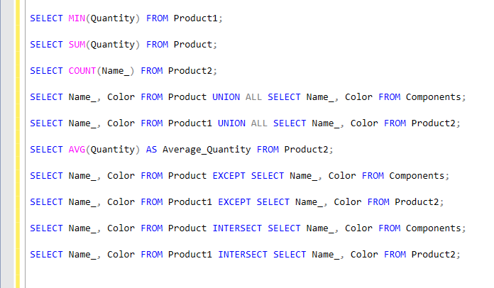

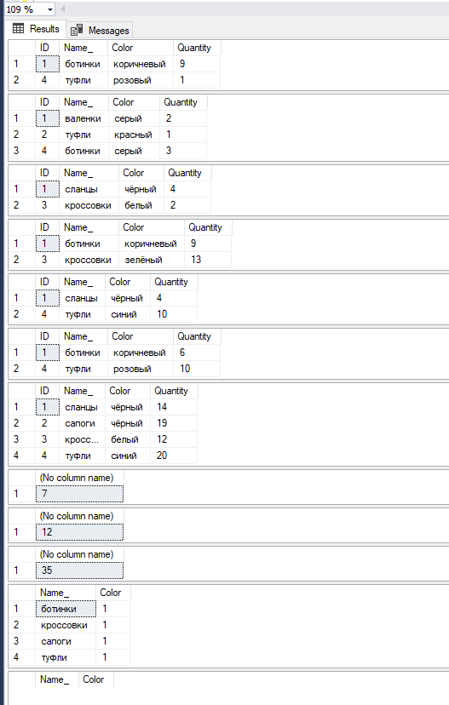

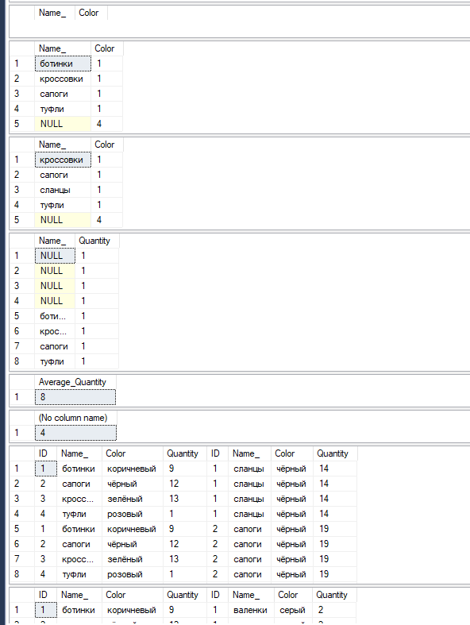

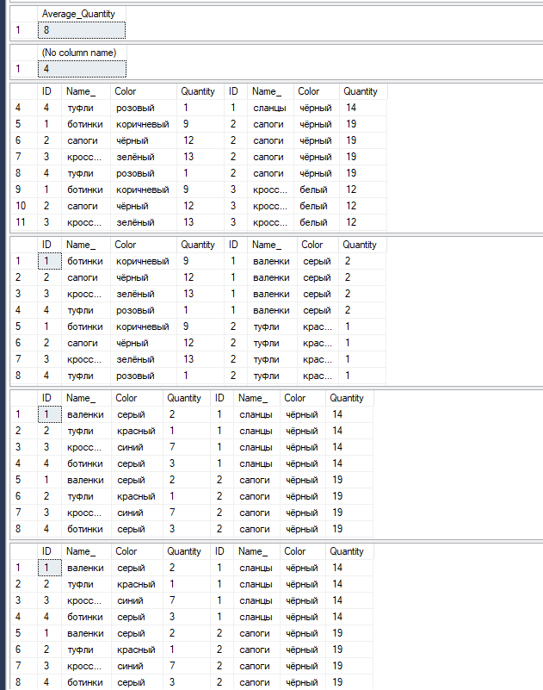

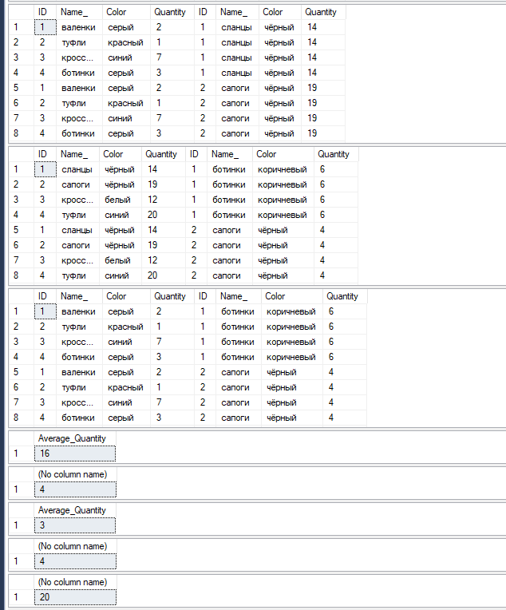

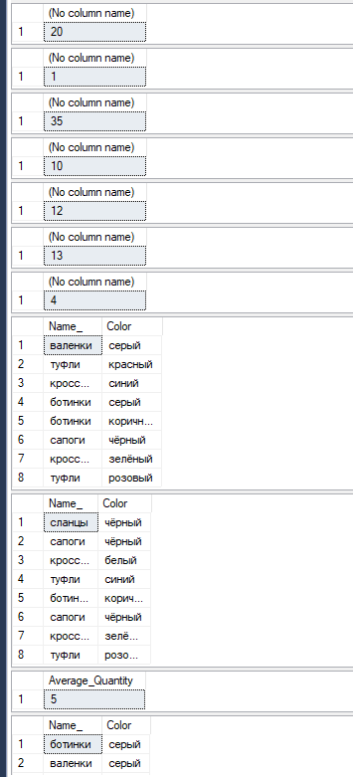

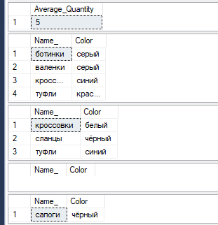

**Задание № 8.1.**

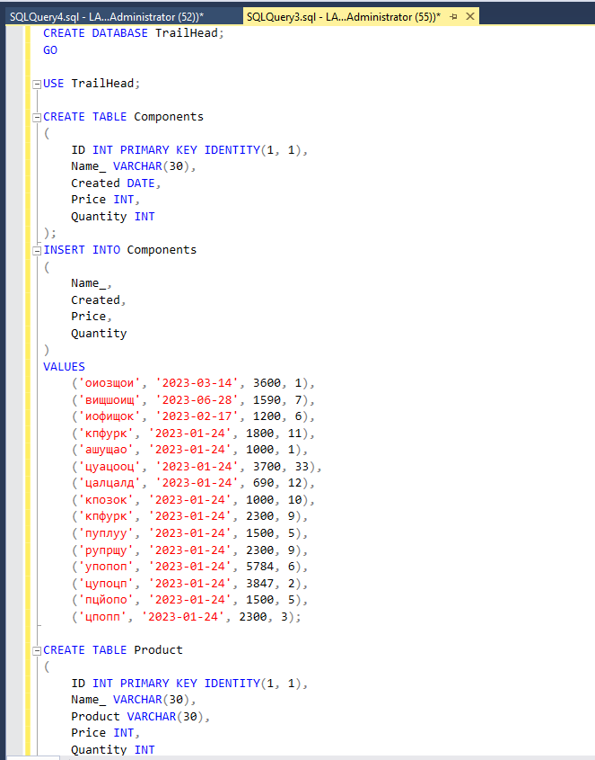

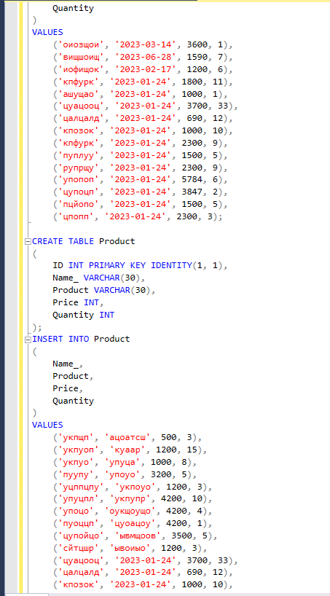

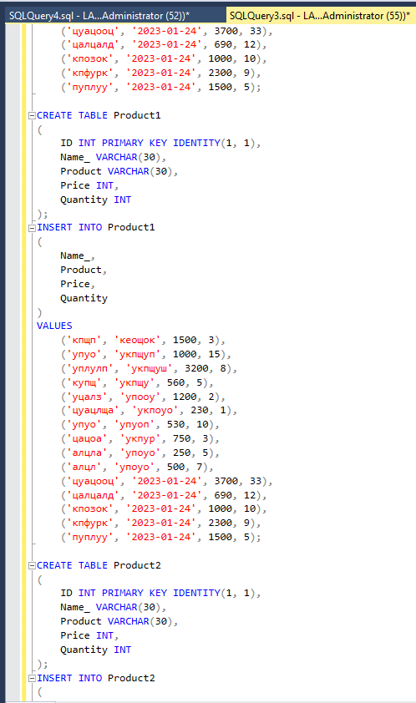

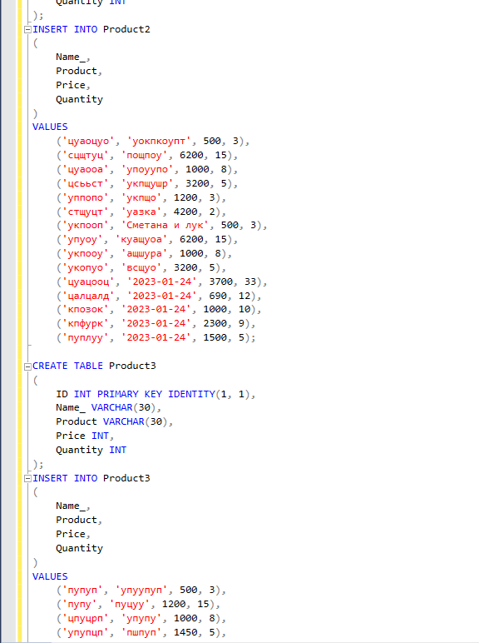

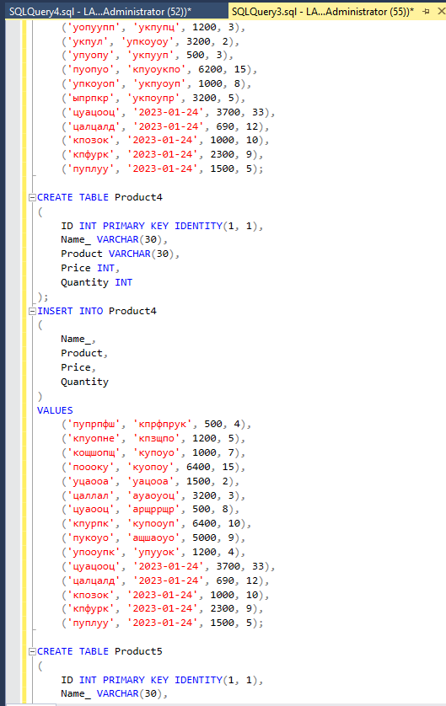

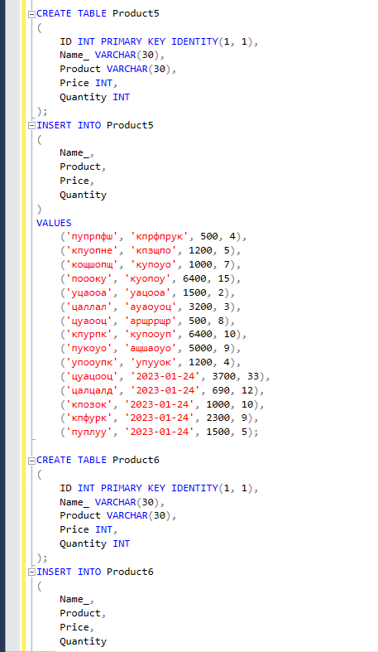

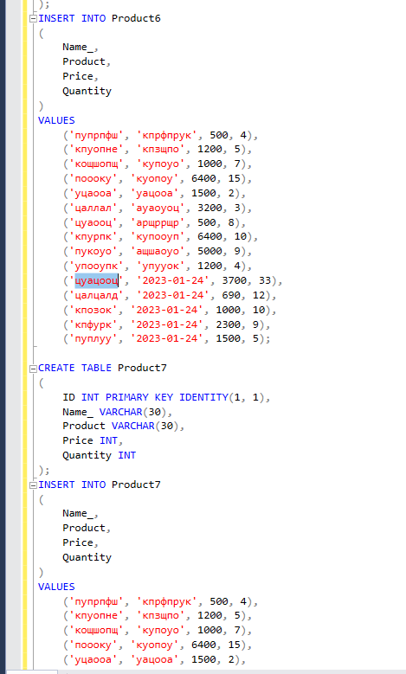

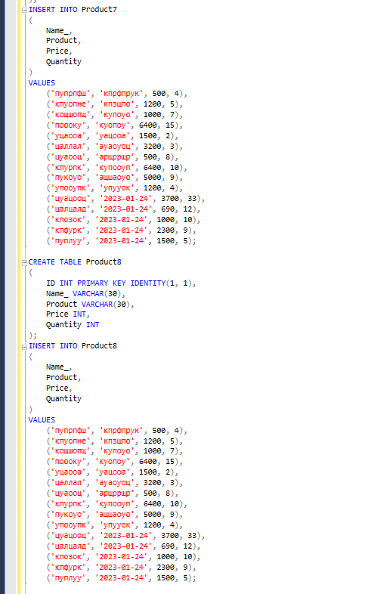

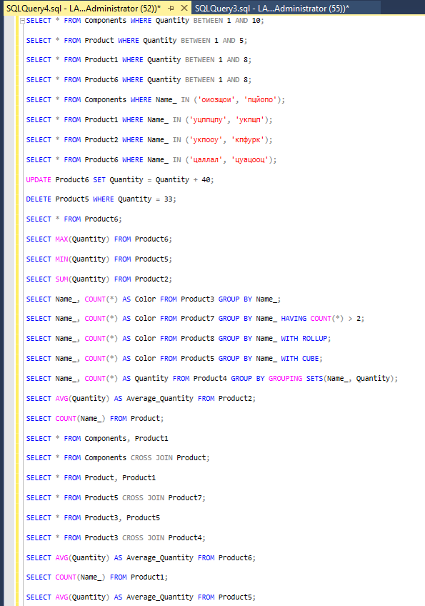

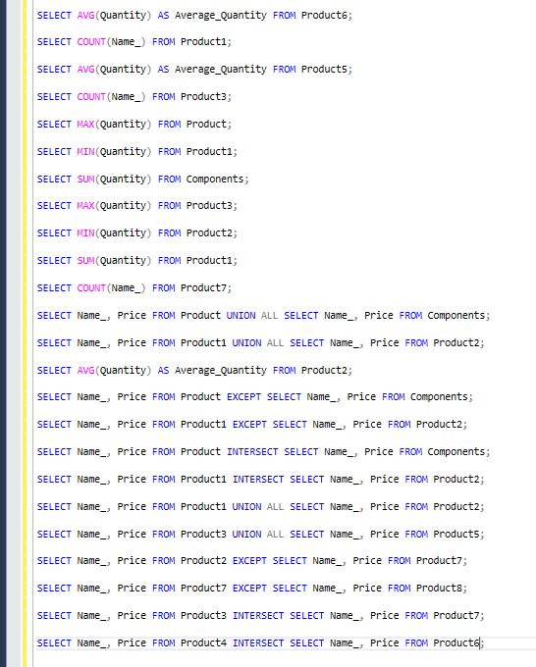

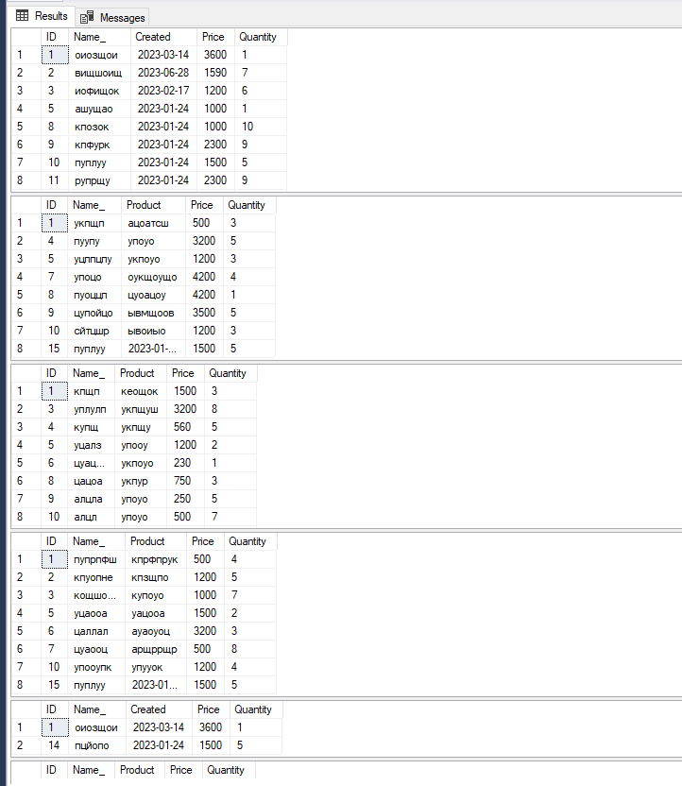

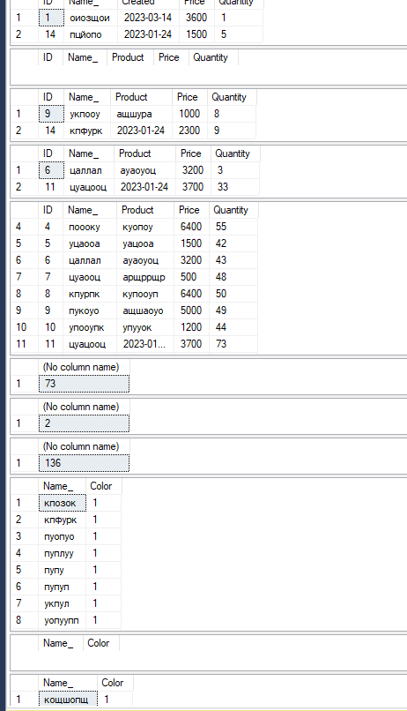

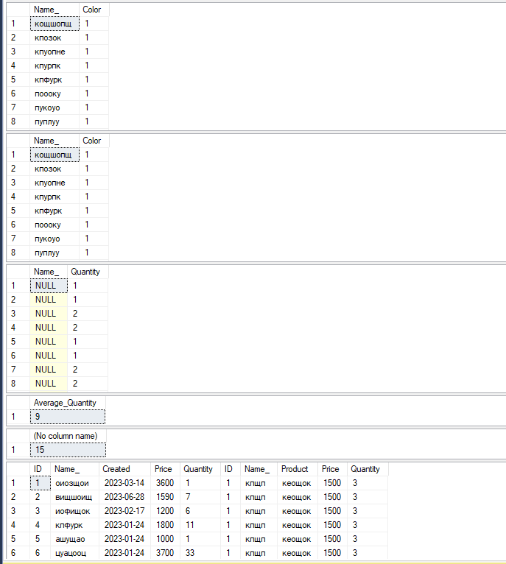

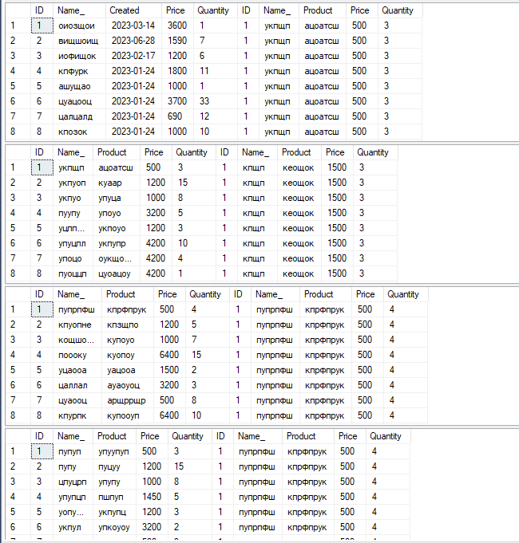

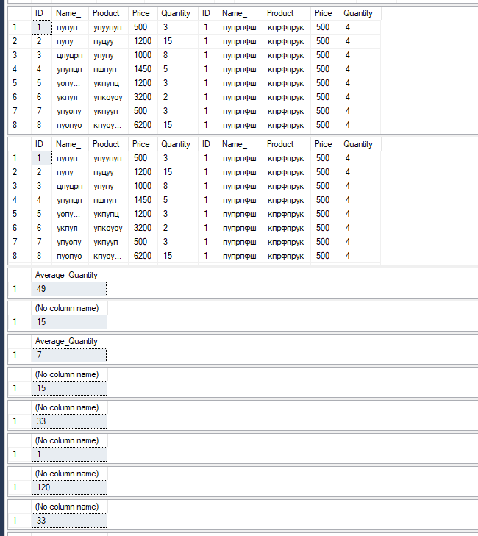

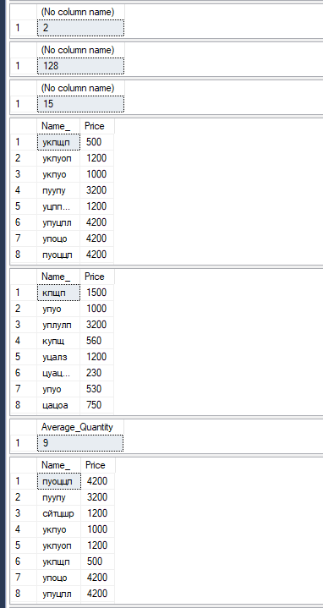

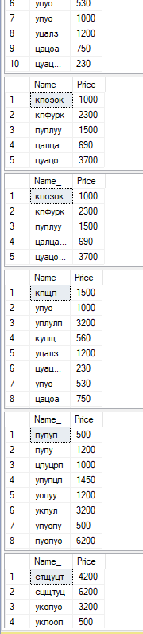

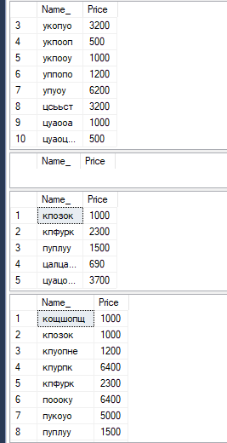

**Задание № 8.2.**

CREATE DATABASE SportShop;

GO

USE SportShop;

CREATE TABLE Components

(

ID INT PRIMARY KEY IDENTITY(1, 1),

Name_ VARCHAR(30),

Created DATE,

Price INT,

Quantity INT

);

INSERT INTO Components

(

Name_,

Created,

Price,

Quantity

)

VALUES

('оиозщои', '2023-03-14', 3600, 1),

('вищшоищ', '2023-06-28', 1590, 7),

('иофищок', '2023-02-17', 1200, 6),

('кпфурк', '2023-01-24', 1800, 11),

('ашущао', '2023-01-24', 1000, 1),

('цуацооц', '2023-01-24', 3700, 33),

('цалцалд', '2023-01-24', 690, 12),

('кпозок', '2023-01-24', 1000, 10),

('кпфурк', '2023-01-24', 2300, 9),

('пуплуу', '2023-01-24', 1500, 5),

('рупрщу', '2023-01-24', 2300, 9),

('упопоп', '2023-01-24', 5784, 6),

('цупоцп', '2023-01-24', 3847, 2),

('пцйопо', '2023-01-24', 1500, 5),

('цпопп', '2023-01-24', 2300, 3);

CREATE TABLE Product

(

ID INT PRIMARY KEY IDENTITY(1, 1),

Name_ VARCHAR(30),

Product VARCHAR(30),

Price INT,

Quantity INT

);

INSERT INTO Product

(

Name_,

Product,

Price,

Quantity

)

VALUES

('укпщп', 'ацоатсш', 500, 3),

('укпуоп', 'куаар', 1200, 15),

('укпуо', 'упуца', 1000, 8),

('пуупу', 'упоуо', 3200, 5),

('уцппцпу', 'укпоуо', 1200, 3),

('упуцпл', 'укпупр', 4200, 10),

('упоцо', 'оукщоущо', 4200, 4),

('пуоццп', 'цуоацоу', 4200, 1),

('цупойцо', 'ывмщоов', 3500, 5),

('сйтцшр', 'ывоиыо', 1200, 3),

('цуацооц', '2023-01-24', 3700, 33),

('цалцалд', '2023-01-24', 690, 12),

('кпозок', '2023-01-24', 1000, 10),

('кпфурк', '2023-01-24', 2300, 9),

('пуплуу', '2023-01-24', 1500, 5);

CREATE TABLE Product1

(

ID INT PRIMARY KEY IDENTITY(1, 1),

Name_ VARCHAR(30),

Product VARCHAR(30),

Price INT,

Quantity INT

);

INSERT INTO Product1

(

Name_,

Product,

Price,

Quantity

)

VALUES

('кпщп', 'кеощок', 1500, 3),

('упуо', 'укпщуп', 1000, 15),

('уплулп', 'укпщуш', 3200, 8),

('купщ', 'укпщу', 560, 5),

('уцалз', 'упооу', 1200, 2),

('цуацлща', 'укпоуо', 230, 1),

('упуо', 'упуоп', 530, 10),

('цацоа', 'укпур', 750, 3),

('алцла', 'упоуо', 250, 5),

('алцл', 'упоуо', 500, 7),

('цуацооц', '2023-01-24', 3700, 33),

('цалцалд', '2023-01-24', 690, 12),

('кпозок', '2023-01-24', 1000, 10),

('кпфурк', '2023-01-24', 2300, 9),

('пуплуу', '2023-01-24', 1500, 5);

CREATE TABLE Product2

(

ID INT PRIMARY KEY IDENTITY(1, 1),

Name_ VARCHAR(30),

Product VARCHAR(30),

Price INT,

Quantity INT

);

INSERT INTO Product2

(

Name_,

Product,

Price,

Quantity

)

VALUES

('цуаоцуо', 'уокпкоупт', 500, 3),

('сцщтуц', 'пощпоу', 6200, 15),

('цуаооа', 'упоуупо', 1000, 8),

('цсььст', 'укпщушр', 3200, 5),

('уппопо', 'укпщо', 1200, 3),

('стщуцт', 'уазка', 4200, 2),

('укпооп', 'Сметана и лук', 500, 3),

('упуоу', 'куащуоа', 6200, 15),

('укпооу', 'ащшура', 1000, 8),

('укопуо', 'всщуо', 3200, 5),

('цуацооц', '2023-01-24', 3700, 33),

('цалцалд', '2023-01-24', 690, 12),

('кпозок', '2023-01-24', 1000, 10),

('кпфурк', '2023-01-24', 2300, 9),

('пуплуу', '2023-01-24', 1500, 5);

CREATE TABLE Product3

(

ID INT PRIMARY KEY IDENTITY(1, 1),

Name_ VARCHAR(30),

Product VARCHAR(30),

Price INT,

Quantity INT

);

INSERT INTO Product3

(

Name_,

Product,

Price,

Quantity

)

VALUES

('пупуп', 'упуупуп', 500, 3),

('пупу', 'пуцуу', 1200, 15),

('цпуцрп', 'упупу', 1000, 8),

('упупцп', 'пшпуп', 1450, 5),

('уопуупп', 'укпупц', 1200, 3),

('укпул', 'упкоуоу', 3200, 2),

('упуопу', 'укпууп', 500, 3),

('пуопуо', 'кпуоукпо', 6200, 15),

('упкоуоп', 'укпуоуп', 1000, 8),

('ыпрпкр', 'укпоупр', 3200, 5),

('цуацооц', '2023-01-24', 3700, 33),

('цалцалд', '2023-01-24', 690, 12),

('кпозок', '2023-01-24', 1000, 10),

('кпфурк', '2023-01-24', 2300, 9),

('пуплуу', '2023-01-24', 1500, 5);

CREATE TABLE Product4

(

ID INT PRIMARY KEY IDENTITY(1, 1),

Name_ VARCHAR(30),

Product VARCHAR(30),

Price INT,

Quantity INT

);

INSERT INTO Product4

(

Name_,

Product,

Price,

Quantity

)

VALUES

('пупрпфш', 'кпрфпрук', 500, 4),

('кпуопне', 'кпзщпо', 1200, 5),

('кощшопщ', 'купоуо', 1000, 7),

('поооку', 'куопоу', 6400, 15),

('уцаооа', 'уацооа', 1500, 2),

('цаллал', 'ауаоуоц', 3200, 3),

('цуаооц', 'арщррщр', 500, 8),

('кпурпк', 'купооуп', 6400, 10),

('пукоуо', 'ащшаоуо', 5000, 9),

('упооупк', 'упууок', 1200, 4),

('цуацооц', '2023-01-24', 3700, 33),

('цалцалд', '2023-01-24', 690, 12),

('кпозок', '2023-01-24', 1000, 10),

('кпфурк', '2023-01-24', 2300, 9),

('пуплуу', '2023-01-24', 1500, 5);

CREATE TABLE Product5

(

ID INT PRIMARY KEY IDENTITY(1, 1),

Name_ VARCHAR(30),

Product VARCHAR(30),

Price INT,

Quantity INT

);

INSERT INTO Product5

(

Name_,

Product,

Price,

Quantity

)

VALUES

('пупрпфш', 'кпрфпрук', 500, 4),

('кпуопне', 'кпзщпо', 1200, 5),

('кощшопщ', 'купоуо', 1000, 7),

('поооку', 'куопоу', 6400, 15),

('уцаооа', 'уацооа', 1500, 2),

('цаллал', 'ауаоуоц', 3200, 3),

('цуаооц', 'арщррщр', 500, 8),

('кпурпк', 'купооуп', 6400, 10),

('пукоуо', 'ащшаоуо', 5000, 9),

('упооупк', 'упууок', 1200, 4),

('цуацооц', '2023-01-24', 3700, 33),

('цалцалд', '2023-01-24', 690, 12),

('кпозок', '2023-01-24', 1000, 10),

('кпфурк', '2023-01-24', 2300, 9),

('пуплуу', '2023-01-24', 1500, 5);

CREATE TABLE Product6

(

ID INT PRIMARY KEY IDENTITY(1, 1),

Name_ VARCHAR(30),

Product VARCHAR(30),

Price INT,

Quantity INT

);

INSERT INTO Product6

(

Name_,

Product,

Price,

Quantity

)

VALUES

('пупрпфш', 'кпрфпрук', 500, 4),

('кпуопне', 'кпзщпо', 1200, 5),

('кощшопщ', 'купоуо', 1000, 7),

('поооку', 'куопоу', 6400, 15),

('уцаооа', 'уацооа', 1500, 2),

('цаллал', 'ауаоуоц', 3200, 3),

('цуаооц', 'арщррщр', 500, 8),

('кпурпк', 'купооуп', 6400, 10),

('пукоуо', 'ащшаоуо', 5000, 9),

('упооупк', 'упууок', 1200, 4),

('цуацооц', '2023-01-24', 3700, 33),

('цалцалд', '2023-01-24', 690, 12),

('кпозок', '2023-01-24', 1000, 10),

('кпфурк', '2023-01-24', 2300, 9),

('пуплуу', '2023-01-24', 1500, 5);

CREATE TABLE Product7

(

ID INT PRIMARY KEY IDENTITY(1, 1),

Name_ VARCHAR(30),

Product VARCHAR(30),

Price INT,

Quantity INT

);

INSERT INTO Product7

(

Name_,

Product,

Price,

Quantity

)

VALUES

('пупрпфш', 'кпрфпрук', 500, 4),

('кпуопне', 'кпзщпо', 1200, 5),

('кощшопщ', 'купоуо', 1000, 7),

('поооку', 'куопоу', 6400, 15),

('уцаооа', 'уацооа', 1500, 2),

('цаллал', 'ауаоуоц', 3200, 3),

('цуаооц', 'арщррщр', 500, 8),

('кпурпк', 'купооуп', 6400, 10),

('пукоуо', 'ащшаоуо', 5000, 9),

('упооупк', 'упууок', 1200, 4),

('цуацооц', '2023-01-24', 3700, 33),

('цалцалд', '2023-01-24', 690, 12),

('кпозок', '2023-01-24', 1000, 10),

('кпфурк', '2023-01-24', 2300, 9),

('пуплуу', '2023-01-24', 1500, 5);

CREATE TABLE Product8

(

ID INT PRIMARY KEY IDENTITY(1, 1),

Name_ VARCHAR(30),

Product VARCHAR(30),

Price INT,

Quantity INT

);

INSERT INTO Product8

(

Name_,

Product,

Price,

Quantity

)

VALUES

('пупрпфш', 'кпрфпрук', 500, 4),

('кпуопне', 'кпзщпо', 1200, 5),

('кощшопщ', 'купоуо', 1000, 7),

('поооку', 'куопоу', 6400, 15),

('уцаооа', 'уацооа', 1500, 2),

('цаллал', 'ауаоуоц', 3200, 3),

('цуаооц', 'арщррщр', 500, 8),

('кпурпк', 'купооуп', 6400, 10),

('пукоуо', 'ащшаоуо', 5000, 9),

('упооупк', 'упууок', 1200, 4),

('цуацооц', '2023-01-24', 3700, 33),

('цалцалд', '2023-01-24', 690, 12),

('кпозок', '2023-01-24', 1000, 10),

('кпфурк', '2023-01-24', 2300, 9),

('пуплуу', '2023-01-24', 1500, 5);

SELECT * FROM Components WHERE Quantity BETWEEN 1 AND 10;

SELECT * FROM Product1 WHERE Quantity BETWEEN 1 AND 5;

SELECT * FROM Product2 WHERE Quantity BETWEEN 1 AND 8;

SELECT * FROM Product7 WHERE Quantity BETWEEN 1 AND 8;

SELECT * FROM Components WHERE Name_ IN ('оиозщои', 'пцйопо');

SELECT * FROM Product1 WHERE Name_ IN ('уцппцпу', 'укпщп');

SELECT * FROM Product2 WHERE Name_ IN ('укпооу', 'кпфурк');

SELECT * FROM Product6 WHERE Name_ IN ('цаллал', 'цуацооц');

UPDATE Product6 SET Quantity = Quantity + 60;

DELETE Components WHERE Quantity = 10;

SELECT * FROM Product6;

SELECT MIN(Quantity) FROM Product6;

SELECT MAX(Quantity) FROM Product5;

SELECT SUM(Quantity) FROM Product2;

SELECT Name_, COUNT(*) AS Color FROM Product8 GROUP BY Name_;

SELECT Name_, COUNT(*) AS Color FROM Product6 GROUP BY Name_ HAVING COUNT(*) > 2;

SELECT Name_, COUNT(*) AS Color FROM Product5 GROUP BY Name_ WITH ROLLUP;

SELECT Name_, COUNT(*) AS Color FROM Product2 GROUP BY Name_ WITH CUBE;

SELECT Name_, COUNT(*) AS Quantity FROM Product1 GROUP BY GROUPING SETS(Name_, Quantity);

SELECT AVG(Quantity) AS Average_Quantity FROM Product4;

SELECT COUNT(Name_) FROM Product1;

SELECT * FROM Components, Product6

SELECT * FROM Components CROSS JOIN Product6;

SELECT * FROM Product, Product5

SELECT * FROM Product7 CROSS JOIN Product8;

SELECT * FROM Product2, Product4

SELECT * FROM Product2 CROSS JOIN Product5;

SELECT AVG(Quantity) AS Average_Quantity FROM Product6;

SELECT COUNT(Name_) FROM Product3;

SELECT AVG(Quantity) AS Average_Quantity FROM Product5;

SELECT COUNT(Name_) FROM Product2;

SELECT MAX(Quantity) FROM Product1;

SELECT MIN(Quantity) FROM Product3;

SELECT SUM(Quantity) FROM Product6;

SELECT MAX(Quantity) FROM Product2;

SELECT MIN(Quantity) FROM Product1;

SELECT SUM(Quantity) FROM Product4;

SELECT COUNT(Name_) FROM Product8;

SELECT Name_, Price FROM Product UNION ALL SELECT Name_, Price FROM Components;

SELECT Name_, Price FROM Product1 UNION ALL SELECT Name_, Price FROM Product2;

SELECT AVG(Quantity) AS Average_Quantity FROM Product2;

SELECT Name_, Price FROM Product EXCEPT SELECT Name_, Price FROM Product3;

SELECT Name_, Price FROM Product1 EXCEPT SELECT Name_, Price FROM Product2;

SELECT Name_, Price FROM Product INTERSECT SELECT Name_, Price FROM Product;

SELECT Name_, Price FROM Product1 INTERSECT SELECT Name_, Price FROM Product2;

SELECT Name_, Price FROM Product1 UNION ALL SELECT Name_, Price FROM Product2;

SELECT Name_, Price FROM Product3 UNION ALL SELECT Name_, Price FROM Product8;

SELECT Name_, Price FROM Product2 EXCEPT SELECT Name_, Price FROM Product3;

SELECT Name_, Price FROM Product7 EXCEPT SELECT Name_, Price FROM Product5;

SELECT Name_, Price FROM Product3 INTERSECT SELECT Name_, Price FROM Product1;

SELECT Name_, Price FROM Product4 INTERSECT SELECT Name_, Price FROM Product7;

